Design and Fabrication of a Multifunctional Robot for Harvesting Areca nut

Samrudh U.P1, T Uma Vidya2 and Shreya Banerjee3

1,2 Final Year B.E Student, Department of Mechanical Engineering, BMS Institute of Technology, Bangalore, India

3Assistant Professor, Department of Mechanical Engineering, BMS Institute of Technology, Bangalore, India

**Abstract.** The main crops grown in south Indian states like Karnataka and Kerala are areca nut and coconut. Skilled labors are essential who can manually climb up the tree for spraying pesticides on the crown and harvest areca nut. Since these tress are very tall so it is mandatory to climb the trees a minimum of five times a year for a successful harvest. The farmers have to climb the trees using their muscle power. Skilled areca nut tree climbers have become very scarce and also they are finding it difficult to spray the insecticides effectively. There is a need to fabricate a device to automate the process of harvesting areca nut to address efficiency, safety and cost effectiveness. This paper proposes a novel design and fabrication of a multifunctional robot for harvesting areca nuts and spraying pesticides. It provides an alternate for traditional manual method. The robot uses a kind of rack and pinion mechanism to move up and down the tree. The movement of the robot is controlled by using an aurdino circuit based remote control. It regulates the motors by using Double Pole Double Throw (DPDT) switch. The motors are coupled to wheels of robot in which the trunk of tree acts like a rack and wheels act as a pinion. The connectivity of the remote and motor is ensured by Bluetooth connection. Specific designed sprayer or a cutter are mounted on the frame of the robot for proper harvest of areca nut**.**

1. **Introduction**

The people in rural areas of south India like Karnataka and Kerala mainly depend on agriculture for their livelihood. The main crops grown are areca nut and coconut. For spraying and applying insecticides on the crown and also for harvesting, skilled labourers have to climb manually up the tree. Such a process looks easy, in reality but it is a laborious and dangerous task. Arecanut trees attain a height of about 60-70 feet. It is mandatory to climb the trees a minimum of five times a year for a successful harvest - twice for the preventive spray against fungal disease, and thrice to harvest the arecanut. Only skilled labourers can carry out these farming operations. They have to climb the trees using muscle power. In an acre that has 550 trees, a labourer has to climb a minimum of 100 to 150 trees. As this involves real hard, physical exertion, younger generations of labourers are losing interest, with potentially harsh implications for arecanut cultivation. The spraying is done in monsoon, while harvest time is typically in summer. It requires skill to climb an areca nut tree. Skilled areca nut tree climbers have become scarce and farmers are finding it difficult to spray the insecticides. There is a need to invent a device to address automation, efficiency, safety and cost effectiveness. The design of the device should be simple enough for villagers to operate, yet work efficiently to appeal to the majority. In some past literatures areca nut tree climbers uses rope and pulley mechanism for climbing [1]. A special type of knife is used to cut the areca nut. The machine can be operated from the ground. It reduces the risk in climbing the tree manually. The design is very simple making it easy for operation by unskilled labour and also maintenance for this machine is low. But this is not completely automated and requires some manual input. Also it is time consuming. Another literature addressed a triangular base frame areca nut tree climbing and spraying machine [2]. It consists of a triangular base frame with three stepped DC motors. Spring loaded mechanism is used for exerting sufficient tension for gripping the tree and nylon rollers are used to achieve the required friction. Maintaining the stability of the structure in motion is difficult. The spring loaded mechanism used is not an efficient design. A product was developed [3] which had two units RH and LH. The climber steps on the pedal of RH unit and subsequently create the downward movement, through which the steel wire rope is stretched and locks the areca tree. Now the LH unit is lifted up by pulling the handle attached to it to climb one step up the tree and the same process is repeated to create the climbing mechanism and to reach the required height. To descend the tree the pedal of RH unit is pushed down and the handle of LH unit is also pulled down alternatively till the bottom of the tree. The main objective of this design is to reduce the effort required to climb the tree. The product makes use of pedal mechanism consist of a T-gripper assembly which locks the areca tree, a box -beam assembly which acts as a supporting member. This process is also not completely automated.

In present days the climbing methods that are been used by the farmer are rope climbing method and rectangle wooden seat climbing method. Rope climber is economical and simple in design which consists of rope of length one meter twisted to the shape of the sandal, the user wears this sandal and climb the tree manually. In rectangle wooden seat climber the user hangs the wooden seat on his back and climbs the tree manually, once he reaches the tree top he ties the wooden seat to the tree and rest on the seat to harvest the areca nut. Although this two methods are simple and economical. It is not safe and cause physical strain to the user. In summary although many device were invented to climb the areca nut tree it was not economical and user friendly. This project aimed to overcome these deficiencies by developing a multifunctional robot for arecanut farming. This research is useful for climbing, cutting the bunch of arecanut and spraying pesticides on single tree to multiple trees. The crops on the tree and its position can be observed with the help of camera attached to the mechanism. It can be the future scope of this present work.

1. **Working methodology**

The arecanut harvesting and spraying machine works on the basic principle of friction that is the relative lateral motion of two solid surfaces in contact. The machine developed consists of a base frame with 3 nylon wheels driven by a high torque geared motor. The machine is having a “L” shape hinges and are on each links for proper movement of links with the variation in size of the tree. A hydraulic pump is used to provide sufficient grip to the wheel on the tree according to the change in the size of the tree. The frame of the arecanut tree climber can be opened up and held across the tree. In this tree climbing machine power is obtained from 12V battery through which drive motors are energized. The remote is used to control the motor. When the drive motor is switched on, the motor rotates the shaft which in turn rotates the wheels. Due to the friction between drive wheel and the bark of the tree machine rises up along the length of the tree. The contact friction between the wheel and tree is maintained with the help of tension springs and grippers on the wheels. The only component which is in contact with the tree is the wheels which are made up of nylon. Hence it doesn’t cause any damage to the bark of the tree. When the setup reaches on top of the tree the drive motor is switched OFF by the remote control unit. The tension of the spring helps to retain the machine at the required height. Now the motors for controlling the nozzle attachment is switched ON with the help of remote for spraying pesticides.

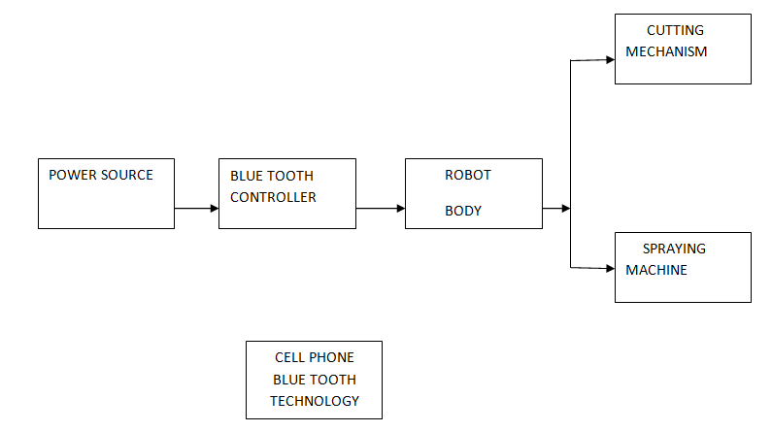

Fig 1. Schematic representation of the complete methodology

The motor unit is capable of rotating in 360˚. The nozzle is mounted on top of the guide way motors. Guide way motors are rotated to the required position in order to spray pesticide to the crop. The nozzle is positioned near the areca nut with the help of guide way motors and then the guide way motors are switched OFF. The wiper pump motor is switched ON and the pesticides is sprayed .After which the pump is stopped and the whole setup is being brought back by changing the polarity of the switch so that the drive motor rotates in opposite direction there by making the wheels rotate in opposite direction. After reaching the ground setup is removed from the tree and attached to the next tree for spraying. During harvesting the cutting blade along with the basket mechanism can be mounted in place of the sprayer. Once the robot reaches the top of the tree the blades cut the crown and the harvest is collected in the basket. This is then bought back to the ground. After reaching ground the setup is removed from the tree and attached to the next tree. This ensures safe handling of the arecanuts ensuring less wastage.

1. **Design calculations**

*3.1 Design of Frame*

Frame design;

For a square angle mild steel channel having dimensions;

b = 25 mm, d= 25 mm, t = 3 mm.

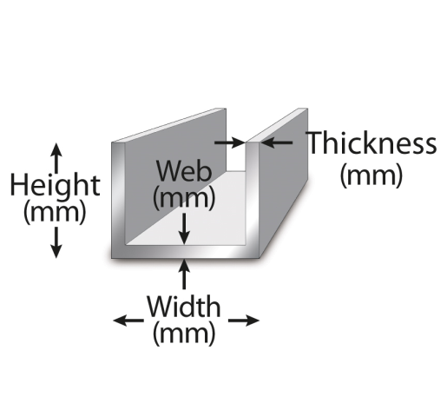

Fig 2. Square angle frame

Consider the maximum load on the frame to be 20 kg.

Max. Bending moment = force*perpendicular distance = 20*9.81*400 (1)

M = 78480 N-mm

We know that [4],

M / I = σb / y (2)

where,

M = Bending moment

I = Moment of Inertia about axis of bending that is;

y = Distance of the layer at which the bending stress is considered (We take always the maximum value of y, that is, distance of extreme fiber from N.A.)

E = Modulus of elasticity of beam material

I = BD^3/12-b*d^3 /12 (3)

I= 25*25^3 / 12 -19*19^3/12

I = 21692 mm4

σb = My /I (4)

σb = 78480*12.5 / 21692

σb = 45.22 N /mm²

*3.2 The allowable shear stress for material*

σall = Syt / fos. (fos- factor of safety) (5)

where, Syt = yield stress

Syt = 210 MPa. [2]

And fos is factor of safety = 2

So,

σall= 210/2

σall = 105 MPa

Comparing above we get,

σb < σall

i.e 45.22 < 105 N/mm²

Hence, design is safe

*3.3 Design of shaft*

M/I = σb/Y (6)

Bending moment=force*perpendicular distance

=5*9.81*450

Bending moment =22072.5Nmm

for diameter 15mm,

I= π/64*d^4 (7)

= π/64*154

I=2483.78 mm4

Therefore, using Eq. (1)

22072.5/5483.78=σb/7.5

σb = 8.86*7.5

σb = 66.64 N/mm²

σb < σall

Hence, design is safe.

*3.4 DC Motor*

Motor specifications used;

Voltage = 4 volt

Current rating <= 13 amps

Speed= 100 rpm

Electrical Power is given by;

P = I * V (8)

P = 250 Watt (rated)

Torque of motor is given by;

P= 2ΠNT / 60 … (9)

T= (P*60) / (2ΠN)

T=(250*60)/(2*3.14*100)

T= 23.8 N-m

(high torque).

# 4. Results

The robot is estimated to climb the tree accurately for the harvest of the areca nut. For analysing the mechanism and to get a complete picture we have performed a finite element analysis in ANSYS.

**4.1 Static structural analysis**

The determination of the effects of [loads](https://en.wikipedia.org/wiki/Structural_load) on physical [structures](https://en.wikipedia.org/wiki/Structure) and their [components](https://en.wikipedia.org/wiki/Structural_engineering#Structural_elements) are determined by structural analysis. Structural analysis employs the fields of [applied mechanics](https://en.wikipedia.org/wiki/Applied_mechanics), [materials science](https://en.wikipedia.org/wiki/Materials_science) and [applied mathematics](https://en.wikipedia.org/wiki/Applied_mathematics) to compute a structure's [deformations](https://en.wikipedia.org/wiki/Deformation_(engineering)), internal [forces](https://en.wikipedia.org/wiki/Force), [stresses](https://en.wikipedia.org/wiki/Stress_analysis), support reactions, accelerations, and [stability](https://en.wikipedia.org/wiki/Structural_stability). The results of the analysis are used to verify a structure's fitness for use, often precluding [physical tests](https://en.wikipedia.org/wiki/Physical_test). Structural analysis is thus a key part of the [engineering design of structure](https://en.wikipedia.org/wiki/Structural_engineering). A static structural analysis determines the displacements, stresses, strains, and forces in structures or components caused by loads that do not induce significant inertia and damping effects

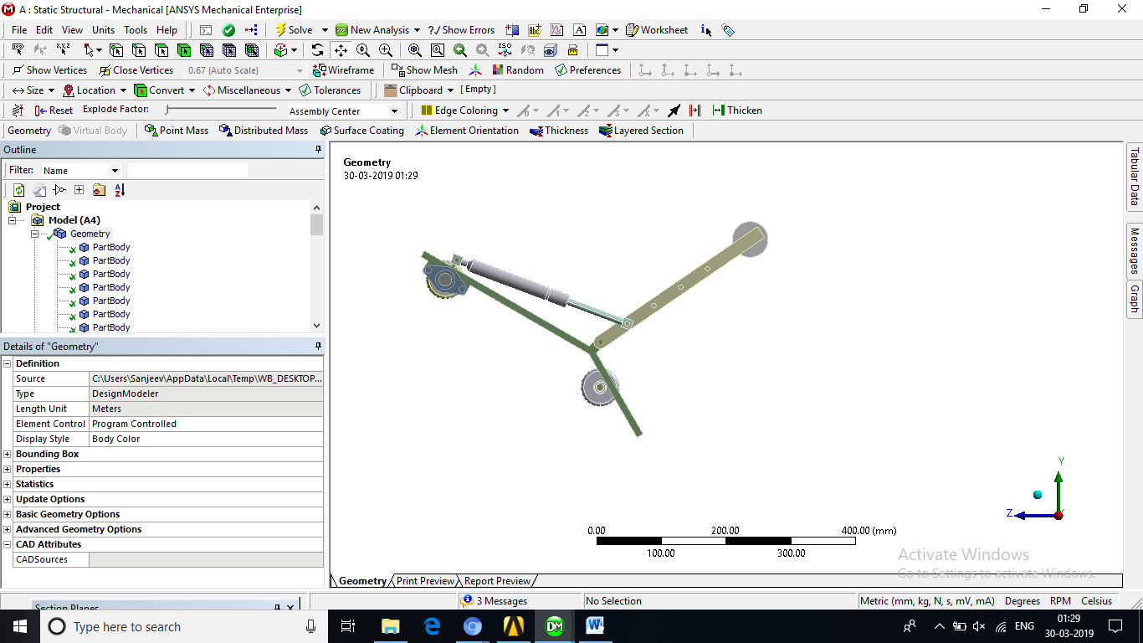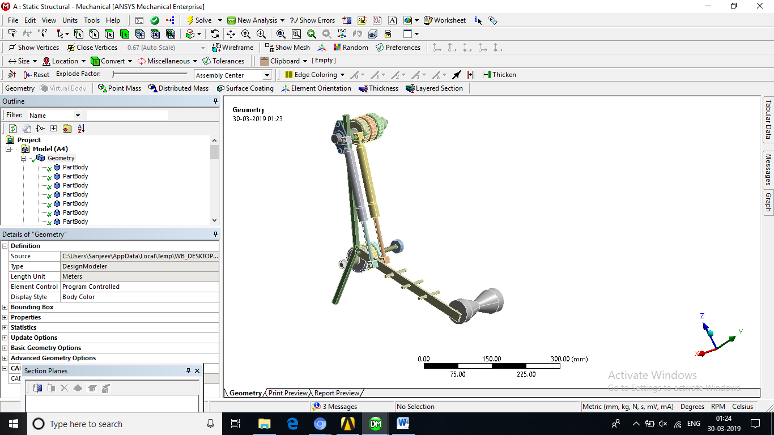

Fig 3**.** 3D model of Areca nut harvester in ANSYS

Meshing is an integral part of the computer-aided engineering simulation process. The mesh influences the accuracy, convergence and speed of the solution. Furthermore, the time it takes to create and mesh a model is often a significant portion of the time it takes to get results from a CAE solution.

**We have used a Hex Dominant Meshing Method,** where a free hex dominant mesh is created. This option is recommended for bodies that cannot be swept. The mesh contains a combination of tet and pyramid cells with majority of cell being of hex type. Hex dominant meshing reduced element count. **The total number of element is 59548**

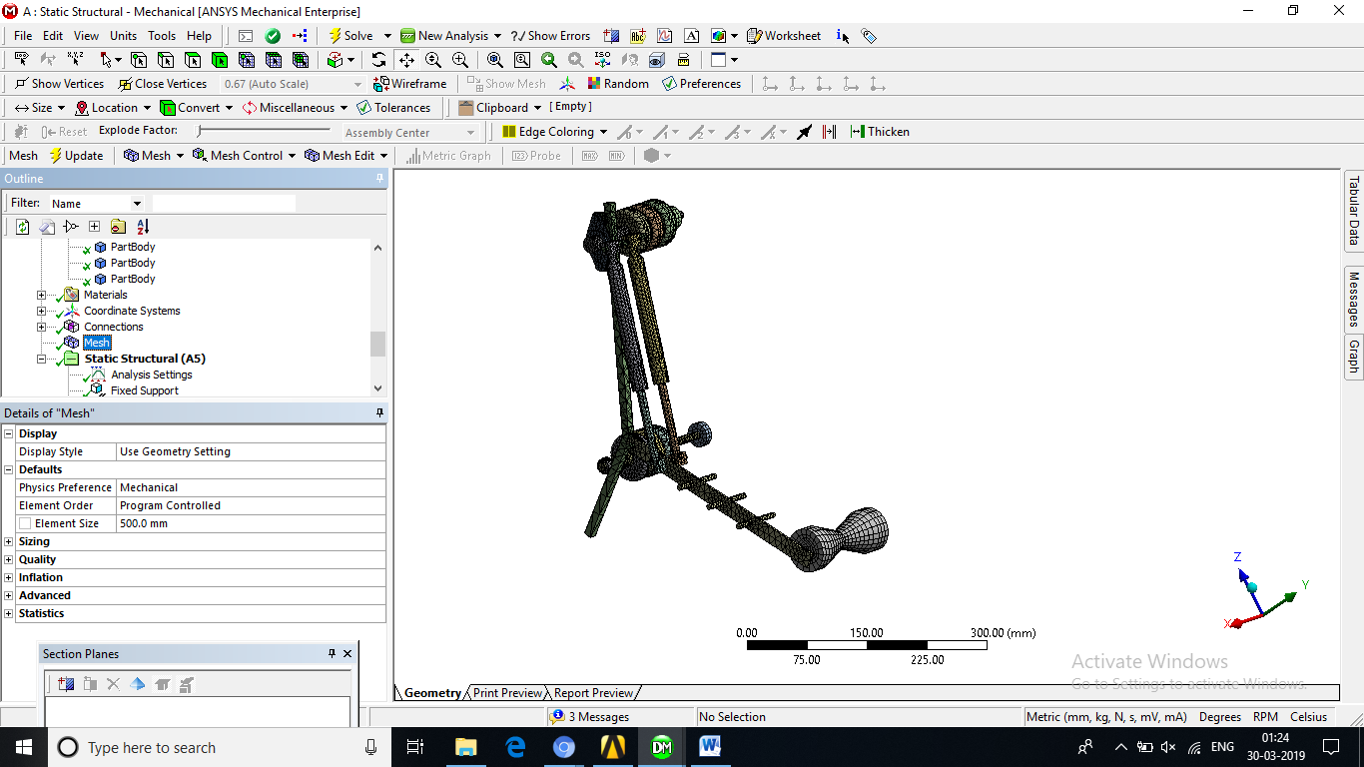

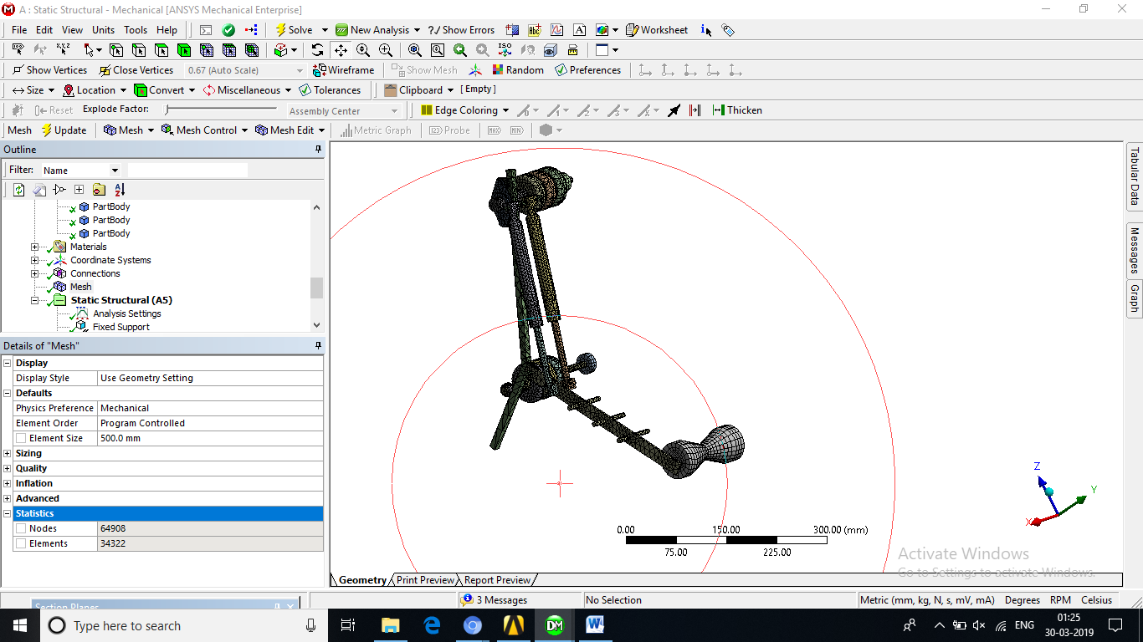

Fig 4**.** 3D meshed model of Areca nut harvester

Boundary conditions are given as a rigid type of connection. It restrains the member in all translations and rotations. The mechanism has been subjected to a load of 10 kg as shown in the Fig 5. For a static load the maximum equivalent stress has been estimated to be around 9.577e-9 around the joining part of the links which is less than the yield stress thus making the design to be safe. But those are also the areas of maximum stress which are the critical areas and optimization techniques can be used to reduce the stress concentration factor.

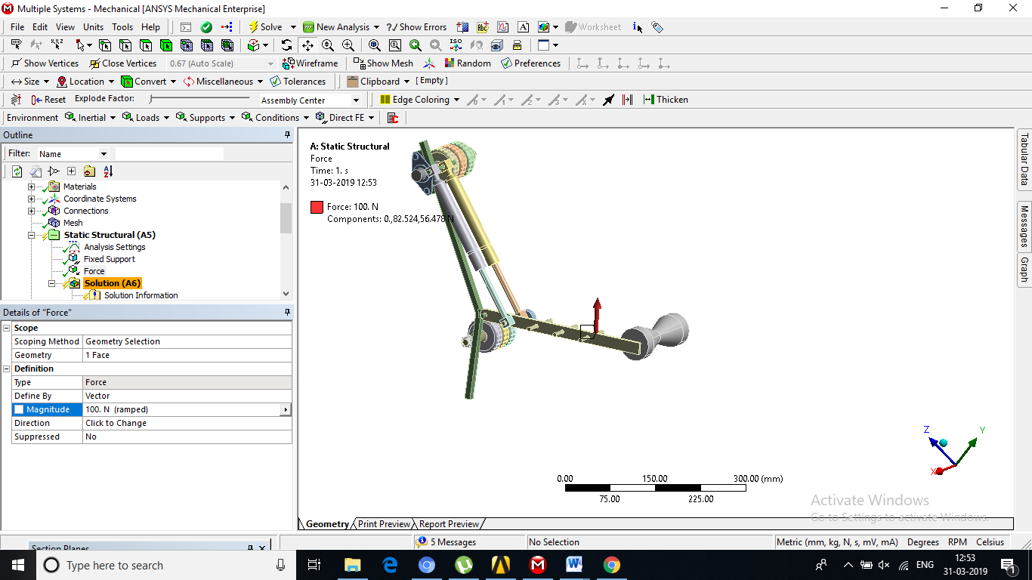

Fig 5. Mechanism under applied load of 10 kg (100 N)

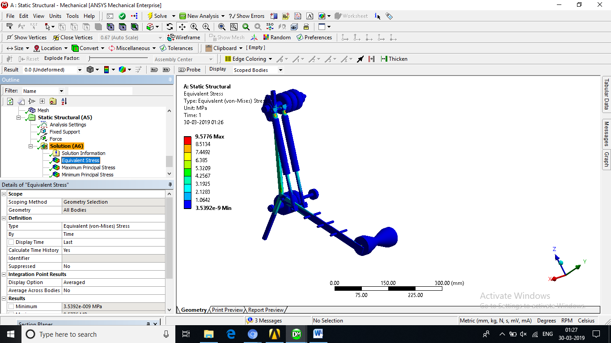

Fig 6. Maximum equivalent stress is 9.5776e-9 MPa which is less then yield stress

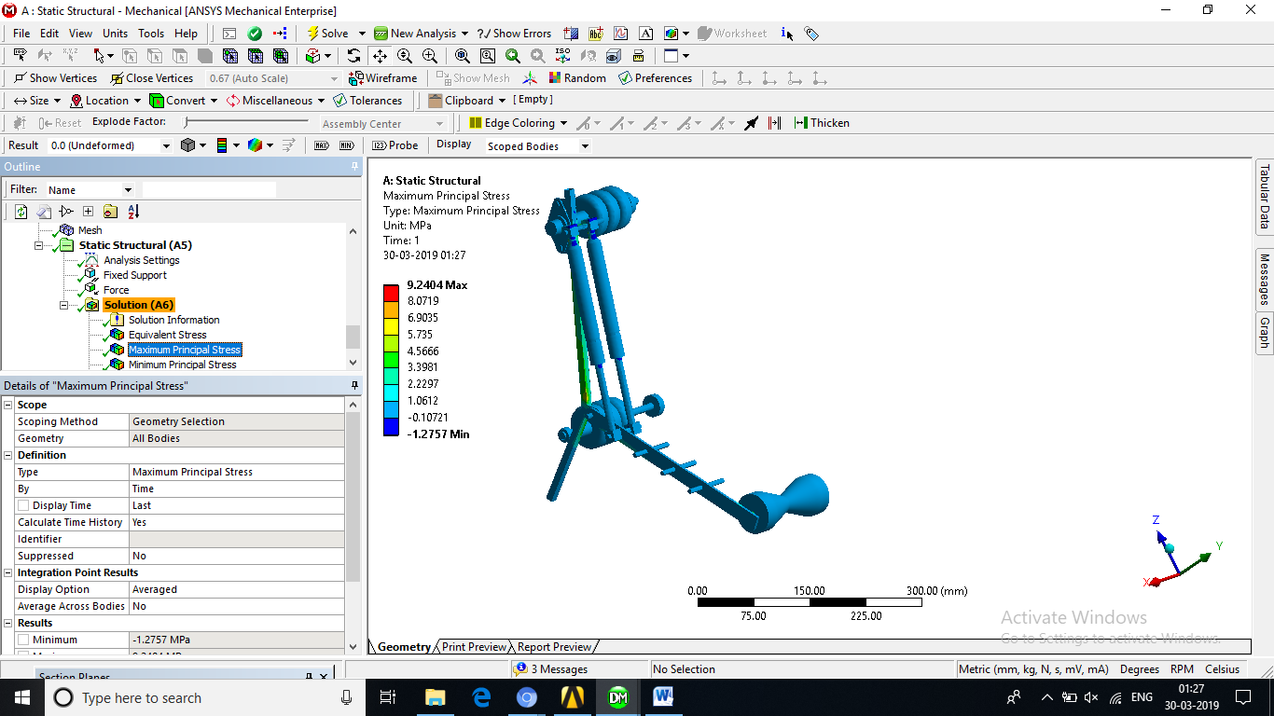

Fig 7. Maximum principal stress is 9.2404 MPa which is less then yield stress

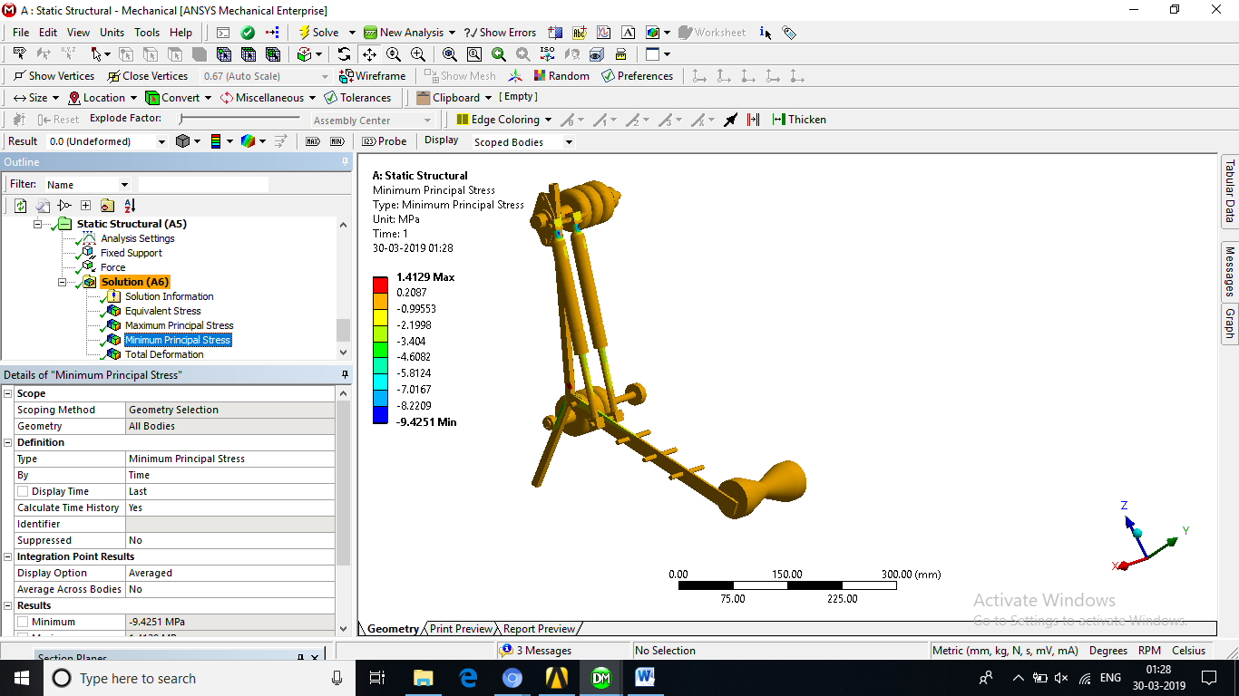

Fig 8. Maximum principal stress is 1.41MPa which is less then yield stress

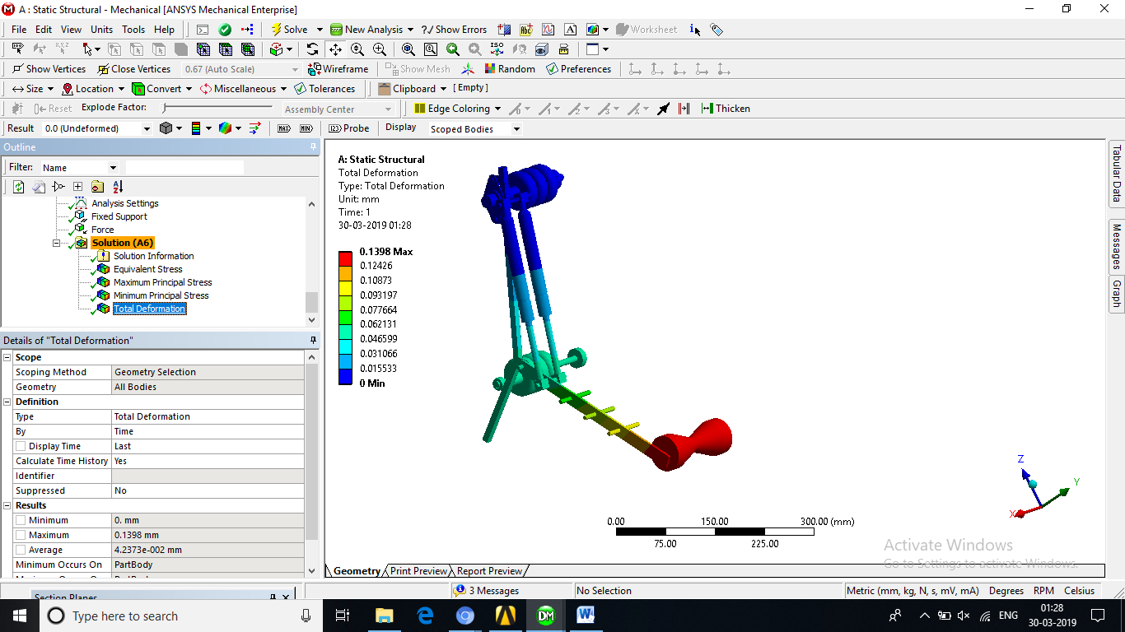

Fig 9. Maximum total deformation is 0.1398 mm

# Conclusion

The robot is roughly estimated to take about 1.30 to 2.0 minutes to climb 40-45 feet trees. From the simulation result it have been found that the maximum equivalent stress is 9.5776e-9 MPa which is less than the yield stress [2] thus it can be concluded that the proposed design is safe. The mechanism will be able to spray pesticides and harvest areca nut with good accuracy, less effort and minimal human involvement. It is portable and easy to operate. The operation is economical.

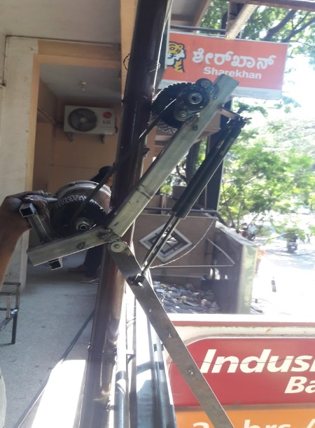

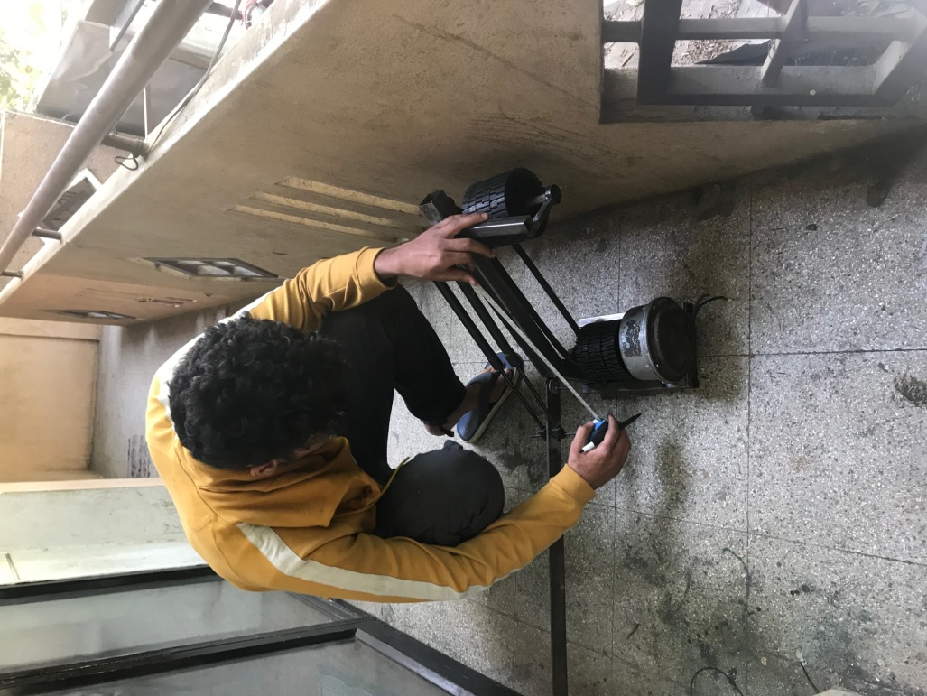

Fig 10. Fabrication of the mechanism

**References**

[1] K.R.Gopalakrishna, Sudhir Gopalakrishna and S.C.Sharma, A text book of Elements of

Mechanical Engineering, Subhas Stores, 26th Edition.

[2] K.Mahadevan and K.Balaveera Reddy, Design Data Hand Book (In SI and Metric Units) For Mechanical Engineers, CBS Publishers and Distributors, 3rd Edition.

[3] J.B.K.Das and P.L.Srinivasa Murthy, Design of Machine Elements 1, Sapna Book House, 3rd Edition.

[4] R.S. Khurmi and J.K. Gupta, A Text Book of Machine Design, Eurasia Publishing House

Pvt. Ltd. Ramnagar, New Delhi,2005 Edition.

[5] Clarence E. Ferguson (1978), Hand Climber for UsewithTree, Birmingham,US Patent

4168765A.

[6] Eliahu Eliachar,H&#39; Eliahu&#39;Mizrachi, Petach Tikva (1992), Tree Climbing Device, Israel,US

[7] Gregory Scott Firth (2013), Pole Saw Guide Patent No: US 20130167434.

[8] Joseph A. Amacker (1992), Tree Climbing, Delhi, US Patent 5090505.

[9] Karl T. Ulrich &amp; Steven D. Eppinger (2007) Product Design and Development”, Third edition,